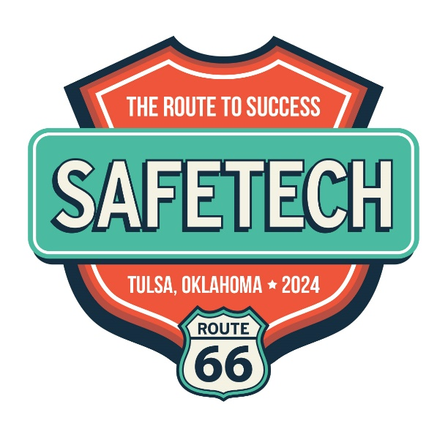

GET YOUR KICKS AT SAFETECH 23!

Join us on Saturday, April 27, 2024 at the Hyatt Regency in Tulsa Oklahoma. Route your Road to success with “key” safe and vault technicians. The family feel of the SAFETECH Convention is the perfect environment for connecting and meeting members in the industry — and getting face to face time with them and introduce your newest product or service!

Drive Success for 2024

- Rev Up Connections
- Drive Customer Interest
- Accelerate Client Relations
- Expand Market Knowledge
- Introduce New Products
- Merge New Partnerships

SHOW INFORMATION

Saturday, April 27, 2024
10 am – 4 pm

Exhibit space rental:

$ 9 per sq. ft. for SAVTA Associate Members
$13 per sq. ft. for Non-Members
$75 for each exposed corner

A 50% Nonrefundable deposit is required
Your Road to Success is in Tulsa
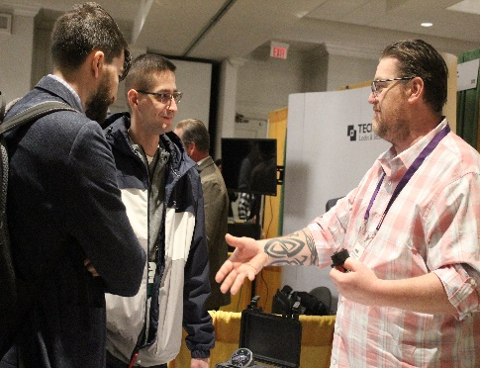
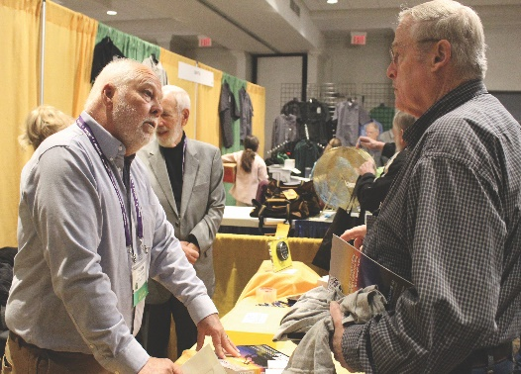

Book A Booth Now!
Call: 912 713-9680 or email kelly@aloa.org.

